email: info@examplecompany.com
phone: 123-555-5555
fax: 123-555-5555

1234 Main Street
City, State 12345
www.examplecompany.com

Example Company Inc. has provided services in environmental and cultural resource consulting for 25 years in the Intermountain area including Idaho and all surrounding states. We retain specialized, highly trained staff who are dedicated to fulfilling each client’s project requirements. Example Company provides a diverse range of project management services relating to the natural and human environment. We have completed projects for private clients as well as state and federal agencies (our accounting system is FAR-compliant). Our expertise is in all areas of environmental documentation including Environmental Evaluations, Environmental Assessments, and Environmental Impact Statements.

Environmental Analysis

- Project Management and facility support  - NEPA Studies  - Wetland Delineation  - Water Quality | - Cultural Resource Clearance  - Biological Assessment  - Noise Analysis  - Air Quality Analysis  - Section 4(f) Analysis

Services
Example Company provides environmental analyses to determine impacts on wetlands; waterways and water quality; sites of cultural, historic, and archaeological significance; wildlife/fish and wildlife/fish habitat including rare, threatened, and endangered species; transportation; noise; air quality; land use; farmlands; Section 4(f) and Section 6(f) lands; displacements and relocations; and hazardous wastes/materials. These analyses may also then be used to develop environmental planning documentation and environmental compliance.

Key Personnel
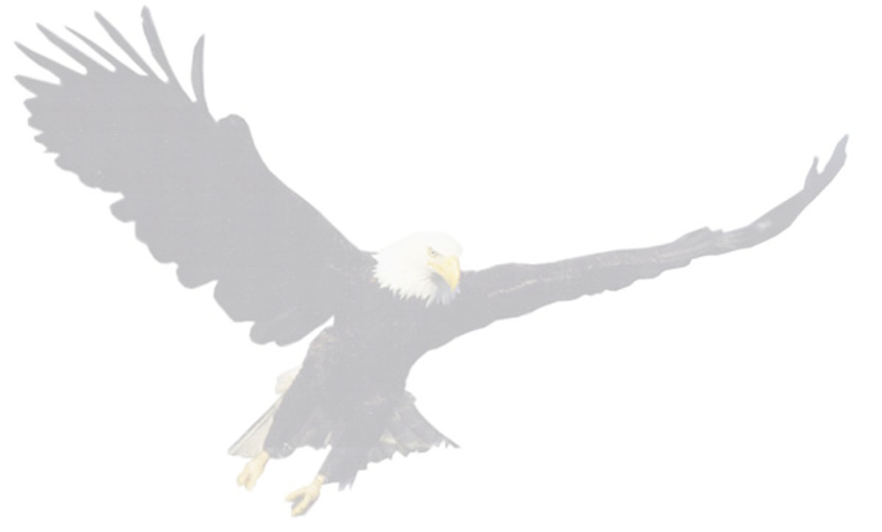
John Doe
Principal—program management, NEPA consultation, noise consultation, and hazardous waste.
Jane Smith
Environmental Project Manager—environmental investigation and assessment, field survey, sampling, and report preparation, water quality analysis, noise analysis, wetland delineation and mitigation planning, and Section 404 of the Clean Water Act permitting.
Bob Jones
Principal Investigator—cultural resource investigations, overall administration and management of cultural resource projects, compilation of cultural resource reports, Section 4(f) evaluations, prehistoric and historic site excavations, recordation of archaeological and historic architectural sites, artifact recordation and preservation, mapping, and supervision of intensive and reconnaissance field surveys.

Areas of Expertise
NEPA Documentation
Example Company will prepare Categorical Exclusions (CE), Environmental Assessments (EA) / Finding of No Significant Impact (FONSI), Environmental Impact Statements (EIS) / Record of Decision (ROD), Environmental Compliance, Environmental Due Diligence Audits, and Environmental Evaluation and Reevaluations for compliance with the National Environmental Protection Act.
Cultural Resource Clearance
Example Company offers professional cultural resource services in all phases of cultural resource investigations including archival research, cultural resource records searches, cultural resources survey, subsurface studies, prehistoric and historic context development and overviews, site prediction and project planning studies, archaeological testing and data recovery excavations—database management, cultural material analysis, section 106 compliance.
Wetlands
Example Company can perform delineations of wetlands and develop wetland mitigation concepts in cooperation with local and state agencies and the Corps of Engineers, to avoid or minimize impacts to wetlands and/or to replace those wetlands. Example Company staff also prepare Section 404 permits.
Biological Assessments
Example Company staff will assure that projects with potential impacts on the environment are compliant with Section 7 of the Endangered Species Act. Staff Consultants will confer with the US Fish and Wildlife Service, and state, local, and tribal wildlife agencies to identify threatened and endangered species that may occur in the project area and prepare the appropriate Biological Assessment.
Water Quality
Example Company will review existing data related to water quality issues in the area and determine if a National Pollution Discharge Elimination System (NPDES) permit and pollution prevention plan need to be prepared.
Hazardous Wastes/Materials
Example Company personnel can perform Phase I property audits which include contacting the Environmental Protection Agency (EPA) and the appropriate state and local environmental divisions to determine if there are any hazardous waste sites, underground storage tanks, or contaminated groundwater in or near the project area.
Noise and Air Quality
Example Company will perform field testing, using an integrating sound level meter, and computer modeling, using the Traffic Noise Model (TNM) 2.0, for noise attributable to any proposed activity by the Federal Highway Administration.
Public/Agency Involvement
Example Company has the ability to manage this process including: public meetings, public hearings, newsletters mailed to interested and affected parties, meetings with public agencies, and continued coordination with affected agencies throughout the duration of any project.

Pertinent Contracts
Idaho Transportation Department
Performed environmental clearance for numerous projects throughout this region. Projects included full environmental assessments involving wetlands delineations, biological assessments, prime farmlands assessments, air and noise studies, cultural resource/archaeological studies, hazardous waste assessments, full Section 4(f) Evaluations, and alternative alignment studies.
Private Wind Development—Idaho and Oregon
Projects included full environmental assessments involving wetlands delineations, biological assessments, prime farmlands assessments, noise studies, cultural resource/archaeological studies, hazardous waste assessments, water quality evaluations, and alternative site selection studies. In addition, post construction avian mortality surveys were completed as well as extensive agency coordination and permitting.
Federal Aviation Administration—Idaho, Oregon, Washington, Montana, Utah
Performed environmental clearance for numerous airport projects throughout this region. Projects included full environmental assessments involving wetlands delineations, biological assessments, prime farmlands assessments, noise studies, cultural resource/archaeological studies, and hazardous waste assessments. In addition to environmental assessments, categorical exclusions, airport master plan updates, and environmental due diligence audits were conducted.

